**Homework 1**

1. Browse and become familiar with the class website including the lab guidelines and etiquette.

*I have browsed the website and went through the semester schedule along with lab guidelines and etiquette.*

1. Set up an account on [TurnItIn.com](http://www.turnitin.com/) using class ID '19952146' and class password 'rooters!'. This will be used for all homeworks, lab assignments, and the research project.

*I am unable to setup an account on Turnitin.com. I will check this with you in class.*

1. Draw a campus network. Don't spend more than 20 minutes on this but be prepared to share your thought process. Hint - Think about the different layers of the OSI model and how they are implemented in hardware. Also think about the geography of most campuses and how they would connect to the internet.

***See next page***

***I have created a campus network diagram with a Router -> Firewall->L3 Switch->Multiple L2 switches-> Access Points/Desktop Machines/Printers.***

***I have also shown a private datacenter which hosts the windows servers, wireless controllers and core switches.***

***The router has connectivity with the ISP. In a real scenario, I would also ensure redundancy with each of these network appliances by adding a HA scenario or failover setup.***

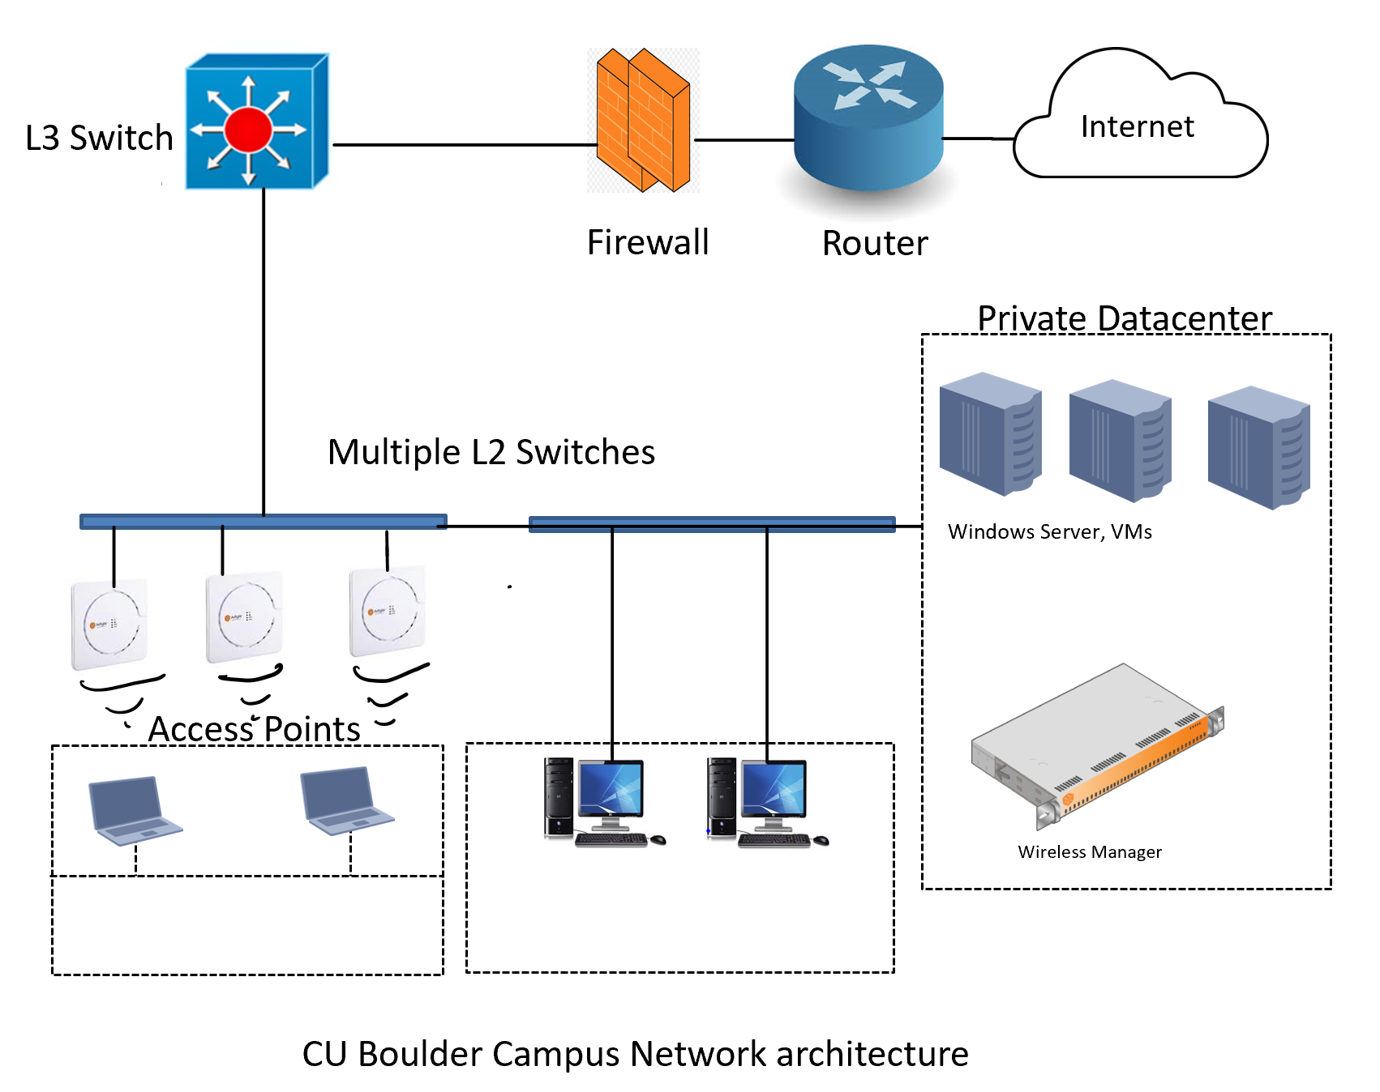

1. Optional: If you use the [LinkedIn](http://www.linkedin.com/) social networking site please add your instructor as a contact. If you don't use the site consider it - it is an invaluable career networking tool.

*Already connected with you before coming for master’s.*